**Apokalypsis**

By Zak Pidd and Charles Purcell

Presented by Next Wave in association with The SUBSTATION

16-20 May 2018

Artist’s Statement

*“They will regard us as people who rearranged the china when the house was on fire.”* Rebecca Solnit, Hope in the Dark

And so we came into this rehearsal process with 100 events that we would aim to portray on stage in an hour, and the understanding that this task would not be completed.

There are an infinite number of ways through history. This is just one. We are drawing attention to a narrative comprised of a list of events that has been curated over a two-year research process. That curation has swung from highly considered criteria and scrutiny to flippant irreverence and back again. Much of what didn’t make it into the final hundred still exists within the work, in moments, images and conversations. As with all lists, however, this one is exclusive of many other worldviews, paradigms and narratives. *Apokalypsis* is defined by the experiences of the people who made it. Climate change has implications for every living person on the planet but the fact that this show is made by some of the (very) lucky ones is not lost on us.

Our generation has inherited a very particular world. Most scientists agree that we have entered the Anthropocene, the “New Age of Humans”, a geological age that for the first time in history has been caused by a living species... us. It is understood that we are staring down the barrel of the most severe mass extinction since the dinosaurs met their fate. And the science is out: we are now past the tipping point. The collective fight against climate change seems hard enough but how do you fight knowing the inevitable futility of your efforts? When all of the information is laid on the table the task seems impossible. We are currently failing. And so, it made sense to set ourselves an impossible task in a theatrical context as a way of exploring this theme: impossible in terms of the how we could represent these events on stage; impossible because climate change is discreet and incremental, which makes it very hard to dramatise; and impossible because of the sheer magnitude and incomprehensibility of this story.

Robert MacFarlane observes that the Anthropocene is an inherently arrogant construct, our crowning act of self-mythologisation, and its exploration perpetuates the myth that got us here in the first place: that human beings are the super species. That said, its existence can not be denied and its exploration is urgent. There is no single answer on how to move forward, but there are conversations to be had. This is our contribution to that conversation.

Zak Pidd & Charles Purcell

Biographies

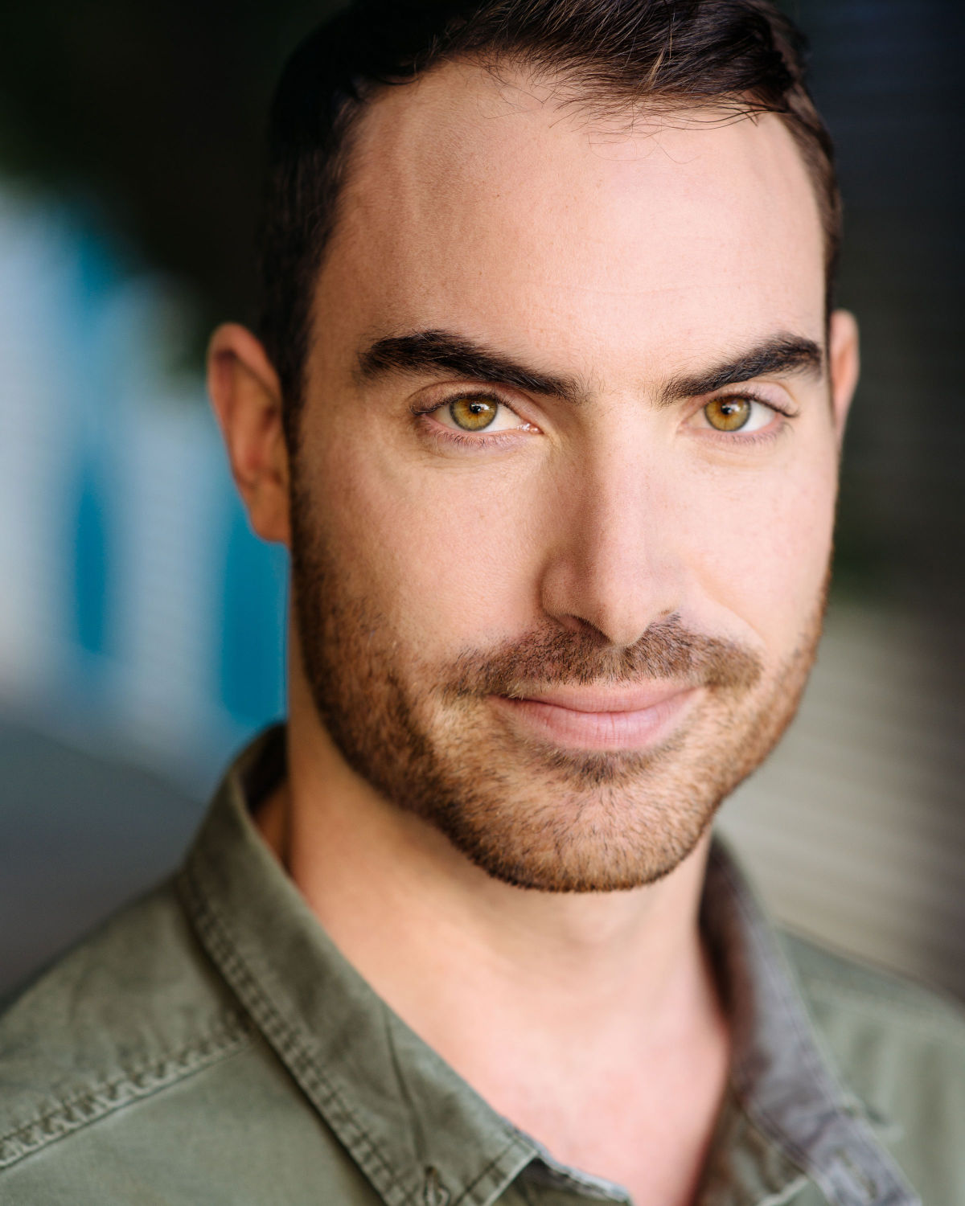

**Charles Purcell**

Co-Creator & Performer

Charles Purcell is a theatre maker and actor who graduated from the Victorian College of the Arts in 2015 with a Bachelor of Fine Arts (Theatre Practice). Recent credits include, as performer: *Colder* (Red Stitch), *Merciless Gods* (Little Ones Theatre / Darebin Speakeasy / Griffin Independent), *Traps* (Melbourne Fringe), *Lifetime Guarantee* and Mark Wilson's *Anti-Hamlet* (Theatre Works), *The Last Ten Minutes of History* (La Mama), Daniel Schlusser's *Schmaltz* (Malthouse) and Bron Batten's *Use Your Illusion* (Field Theory), as performer and co-creator: *Smithereens* (Melbourne Fringe), and as performer and dramaturg: Tim Spencer's *Show Me Yours, I’ll Show You Mine* (Melbourne Fringe / La Boite) which won Melbourne Fringe Awards for Best Performance and Innovation in Theatre and saw Charles nominated for a Green Room Award for Best Male Performer. *Apokalypsis* is Charles' second major collaboration with Zak Pidd.

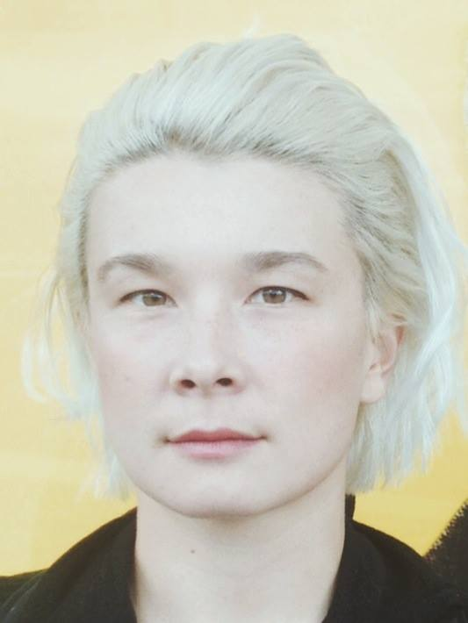

**Kai Bradley**

Co-Creator & Performer

Kai graduated from the Victorian College of the Arts in 2014. Their recent performing credits include: Evanescence (Amos Gebhardt, Adelaide Biennale), STEM (Leigh Whannell, Goalpost Pictures), There Are No Others (Amos Gebhardt), GROUND CONTROL (Rachel Perks & Bridget Balodis, Next Wave Festival), Plus Sign Attached (Maude Davey, VCA) and The Breath of Empty Space (Tom Healey, VCA). In 2016, Kai, with performance artists Embittered Swish, were awarded the Stephen Cummins Bequest Queer Performance Residency (PACT) to develop an adaptation of Jean Genet’s

‘Our Lady of the Flowers’.

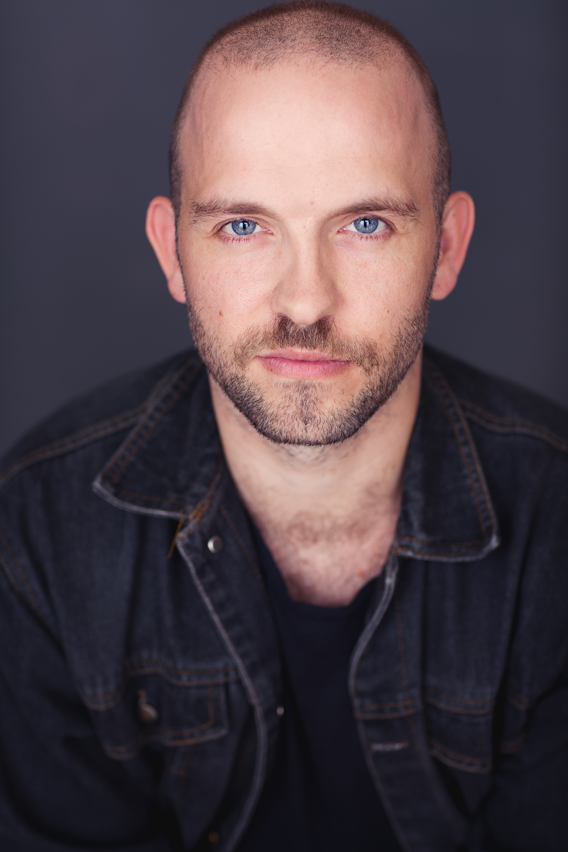**Marcus McKenzie**

Co-Creator & Performer

Marcus is a Melbourne based actor and performance maker. His most recent major work, *HYPERSPIRIT,* was nominated for Best Performance in the 2016 Melbourne Fringe and Best Sound Design in the Melbourne Greenroom Awards. Artists and companies Marcus has worked with recently include Tim Crouch (UK); Hermann Nitsch (AT); Gavin Quinn (IR); Xavier LeRoy (FR); Jai Leeworthy; Geoffrey Watson; Shian Law; Belvoir Street Theatre, Malthouse Theatre, Arena Theatre Company, Red Stitch, New Working Group; and Pony Express. In 2017 he participated in Melbourne Festival’s Directors’ Lab intensive. In 2018 he will collaborate with House of Vnholy as a performer in *Seer* for Next Wave, and assist New York artist Michael Portnoy on a new project in Vienna. In the past 12 months Marcus has received fellowships from both Mike Walsh Foundation and Ian Potter Cultural Trust.

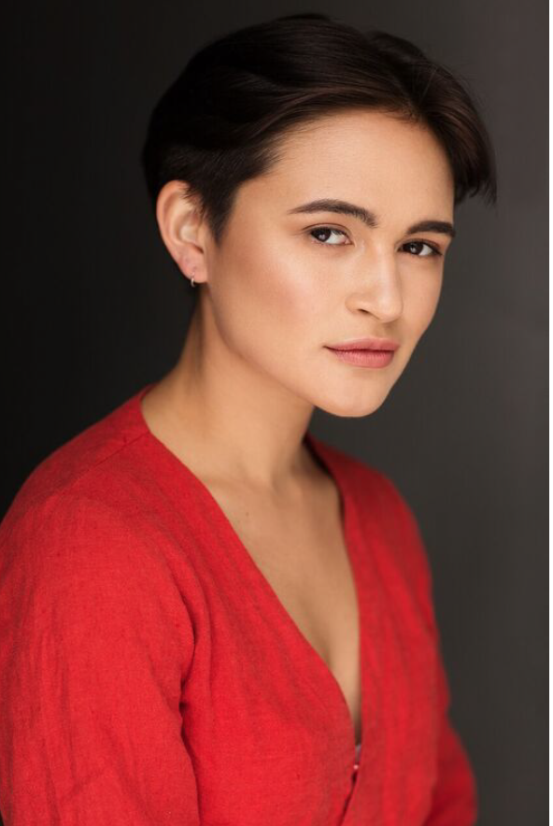

**Rosie Clynes**

Co-Creator & Performer

Rosie Clynes is an award-winning actor, performance maker and proud Balinese-Australian woman. Since graduating from the Victorian College of the Arts in 2015, her psychedelic, jazz-infused work has seen multiple Greenroom Award nominations and a Best Cabaret award at Melbourne Fringe 2016. Her performance work has also taken her to Central Java, Indonesia, where she spent last year as resident artist at the acclaimed Teater Garasi. She has been the recipient of the Hamer Scholarship, VCA’s Lionel Gell Scholarship and later this year will undertake an Asialink Artist Exchange as resident artist at Komunitas Salihara in Jakarta. She is passionate about diversity in the Australian arts landscape, and bases her work upon the interrogation of identity, modern anxiety and connection to ancestry. Other acting credits include ‘Bagaimana Menghilang Sepenuhnya’ (Ark Gallery, Yogyakarta), ‘Vanishing Act’ (Melbourne Fringe 2016), ’I Sat and Waited But You Were Gone Too Long (La Mama and National Play Festival) and ‘Smithereens’ (FR!SK Festival VCA).

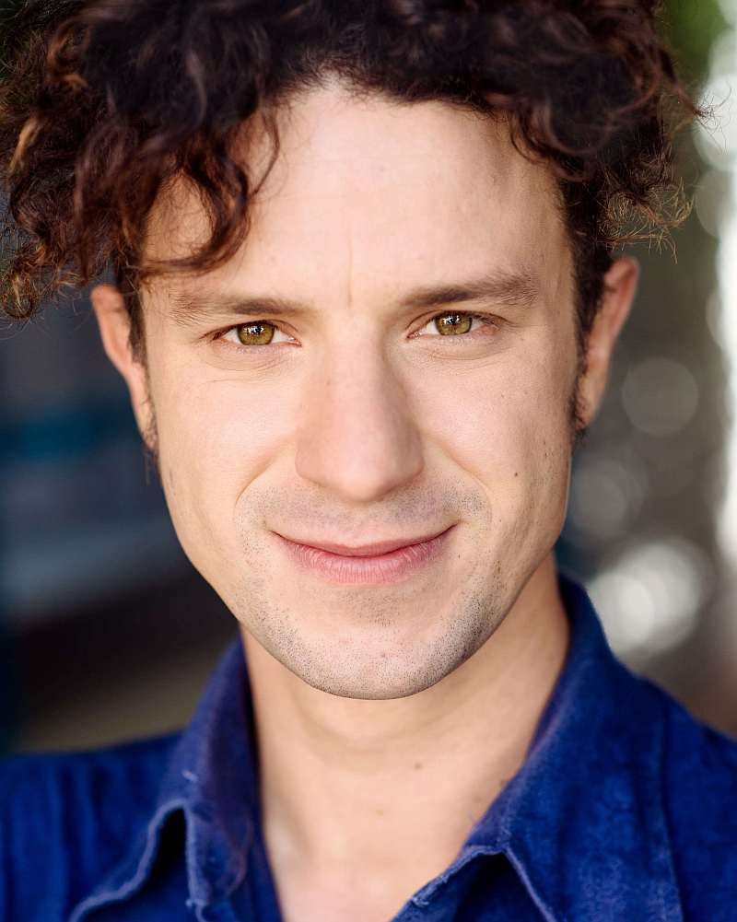**Zak Pidd**

Co-Creator & Sound Design

Zak Piddis a performer and sound designer based in Melbourne. They completed VCA’s Bachelor of Fine Arts Theatre Practice course in 2015. Recently Zak worked as musical director/composer for *Vanishing Act* which won Best Cabaret at Melbourne Fringe 2016 and was nominated for four Green Room Awards including Best Musical Direction. Zak's recent performance credits include *KillJoy* (Melbourne Fringe 2017, nominated for Best Circus), *(in)tent* (Melbourne Fringe 2016) and the world premiere of *Credentials* by David Williamson which they also sound designed (La Mama 2017). Their film credits include *Prasizzler Queen of the Dessert* and the award winning *Tasty*. Zak frequently performs with Polyglot Theatre and has toured with them nationally and internationally. They are currently creating a work titled *Apokalypsis* for Next Wave Festival’s 2018 program which is being supported by its Kickstarter Helix program.

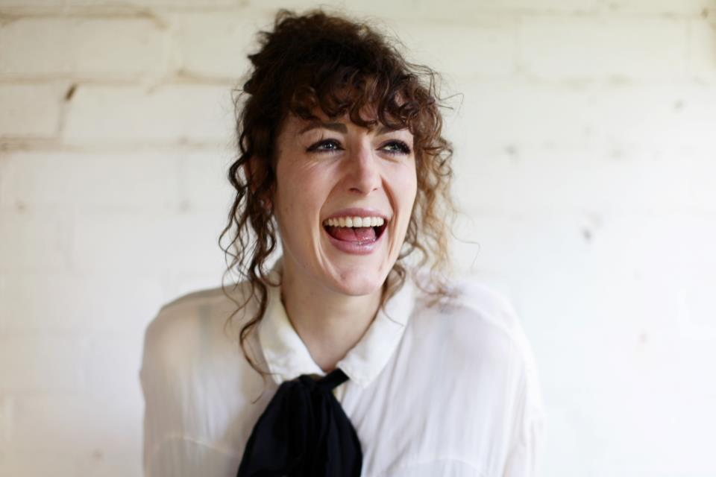

**Katy Maudlin**

Dramaturgy

Katy Maudlin is a director and dramaturge who has worked extensively across Australia, New Zealand and Europe. Her work, *Right Now* by Catherine Anne-Toupin, is currently showing at Red Stitch Actors’ Theatre. Earlier in 2018, she recently directed *AntigoneX,* by Zachary Dunbar, at Theatre Works (Midsumma 2018). She was the 2017 Graduate Director at Red Stitch Actors’ Theatre. During her masters, which she completed at the VCA, Katy undertook a secondment with Katie Mitchell, on *Lucia Di Lammermoor*, at the Royal Opera in London and travelled to Rijeka for a residency with the Croatian National Theatre. There she worked with director Oliver Frljić on *Our Violence, Your Violence*, which was performed as part of the 2016 Vienna Festwochen and as an assistant director to Marin Blazevic on Handel’s *Giulio Cesare*. She has worked as an assistant director to Clare Watson on *Lungs* at Melbourne Theatre Company (MTC) and *i saw the second one hit* (St Martins Youth Arts). She was the recipient of the Melbourne Global Scholars Award (2016) and the Orloff Family Charitable Trust Scholarship (2015).

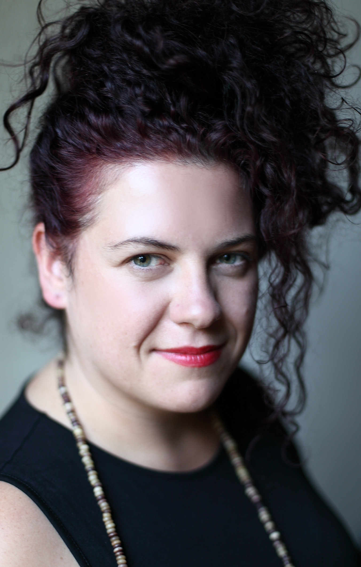**Katie Sfetkidis**

Lighting Design  
  
Katie Sfetkidis is a lighting designer and co-artistic director of Little Ones Theatre Company.  She is the winner of a 2015 Green Room Award for her work on Meme Girls (Malthouse Theatre). Previous Next Wave shows include: Madonna Arms; Liberate Myself from Your Vice-Like Grip!!; The Elephant at the Station. Other credits include:  Little Ones Theatre: Nightingale and the Rose; Merciless Gods; The Happy Prince; Dracula; Dangerous Liaisons; The House of Yes; Salomé; Psycho Beach Party Melbourne Theatre Company: Abigail's Party; Happy Ending Malthouse Theatre: Meme Girls; Calpurnia Descending; Tame She Said: Hart Red Stitch: The Moors; The Laramie Project: Ten Year Later  Belvoir Theatre: Kill the Messenger Sydney Chamber Opera: Oh Mensch (set & lighting); Exil. Katie also has a contemporary art practice focused on performance and video. She recently completed her Masters of Contemporary Art at the Victorian College of the Arts where she received the National Gallery of Victoria's Women's Association Prize.

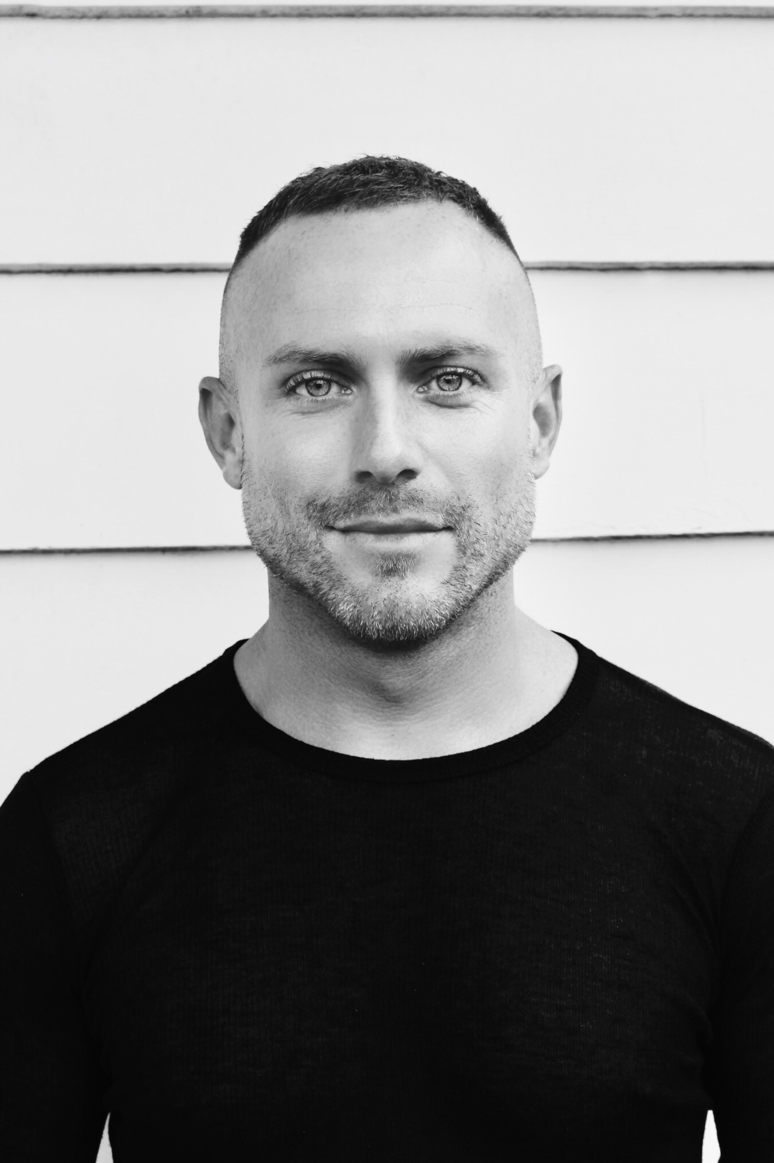

**Jonathan Hindmarsh**

Set & Costume Design

Jonathan is a Sydney based production designer. He is a graduate from NIDA Design in 2015 BA in Theatre at UNSW. Jonathan’s recent design work includes set and costumes for the Griffin Award winning play *Kill Climate Deniers* (Griffin Theatre 2018) and *Metamorphoses* (Apocalypse Theatre Co 2018). In 2017 Jonathan was the resident designer at Sydney’s Old Fitz Theatre, for which he designed the set for *A View From the Bridge*, *The Judas Kiss* and set and costumes for *Doubt*: *A Parable*, *Crimes of the Heart.* His work also includes set design for *Look Back in Anger* (2016), set & costumes for *Low Level Panic* (2016), costumes for Sport For Jove’s *Away* (2016), set for *Belleville* (2016), set and costumes for *The Cherry Orchard* (2016), *Teacup in a Storm* at Q Theatre (2016) and *Intoxication* at Midsumma Festival 2016. Jonathan recently assisted designer Elizabeth Gadsby on *Dinner* (STC 2017) and *The Rape of Lucretia* (SCO 2017).

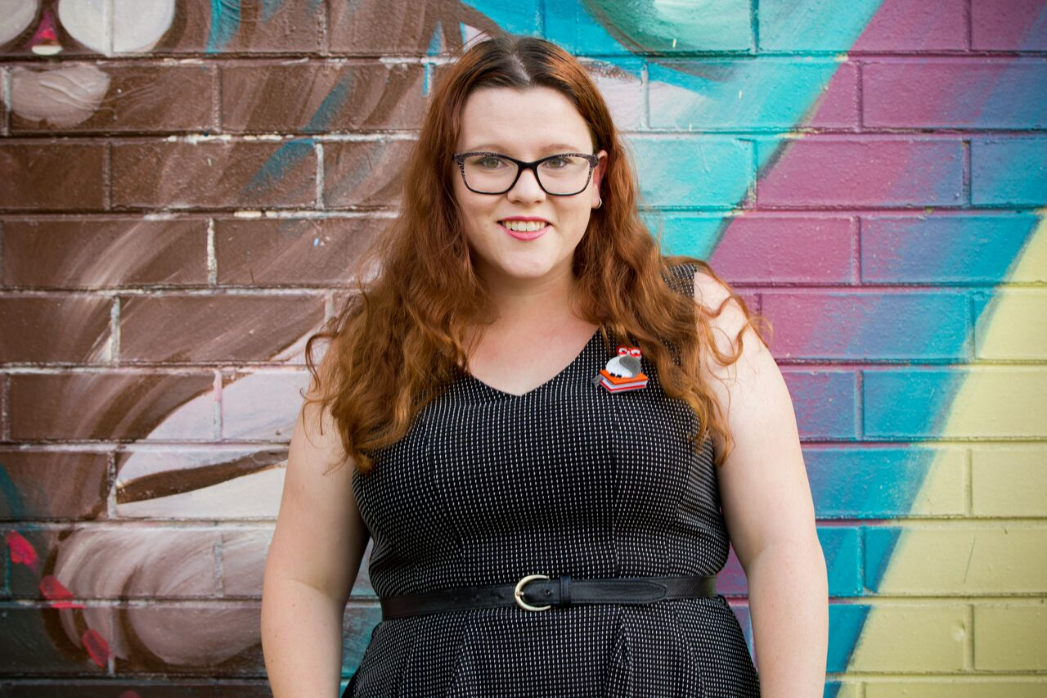**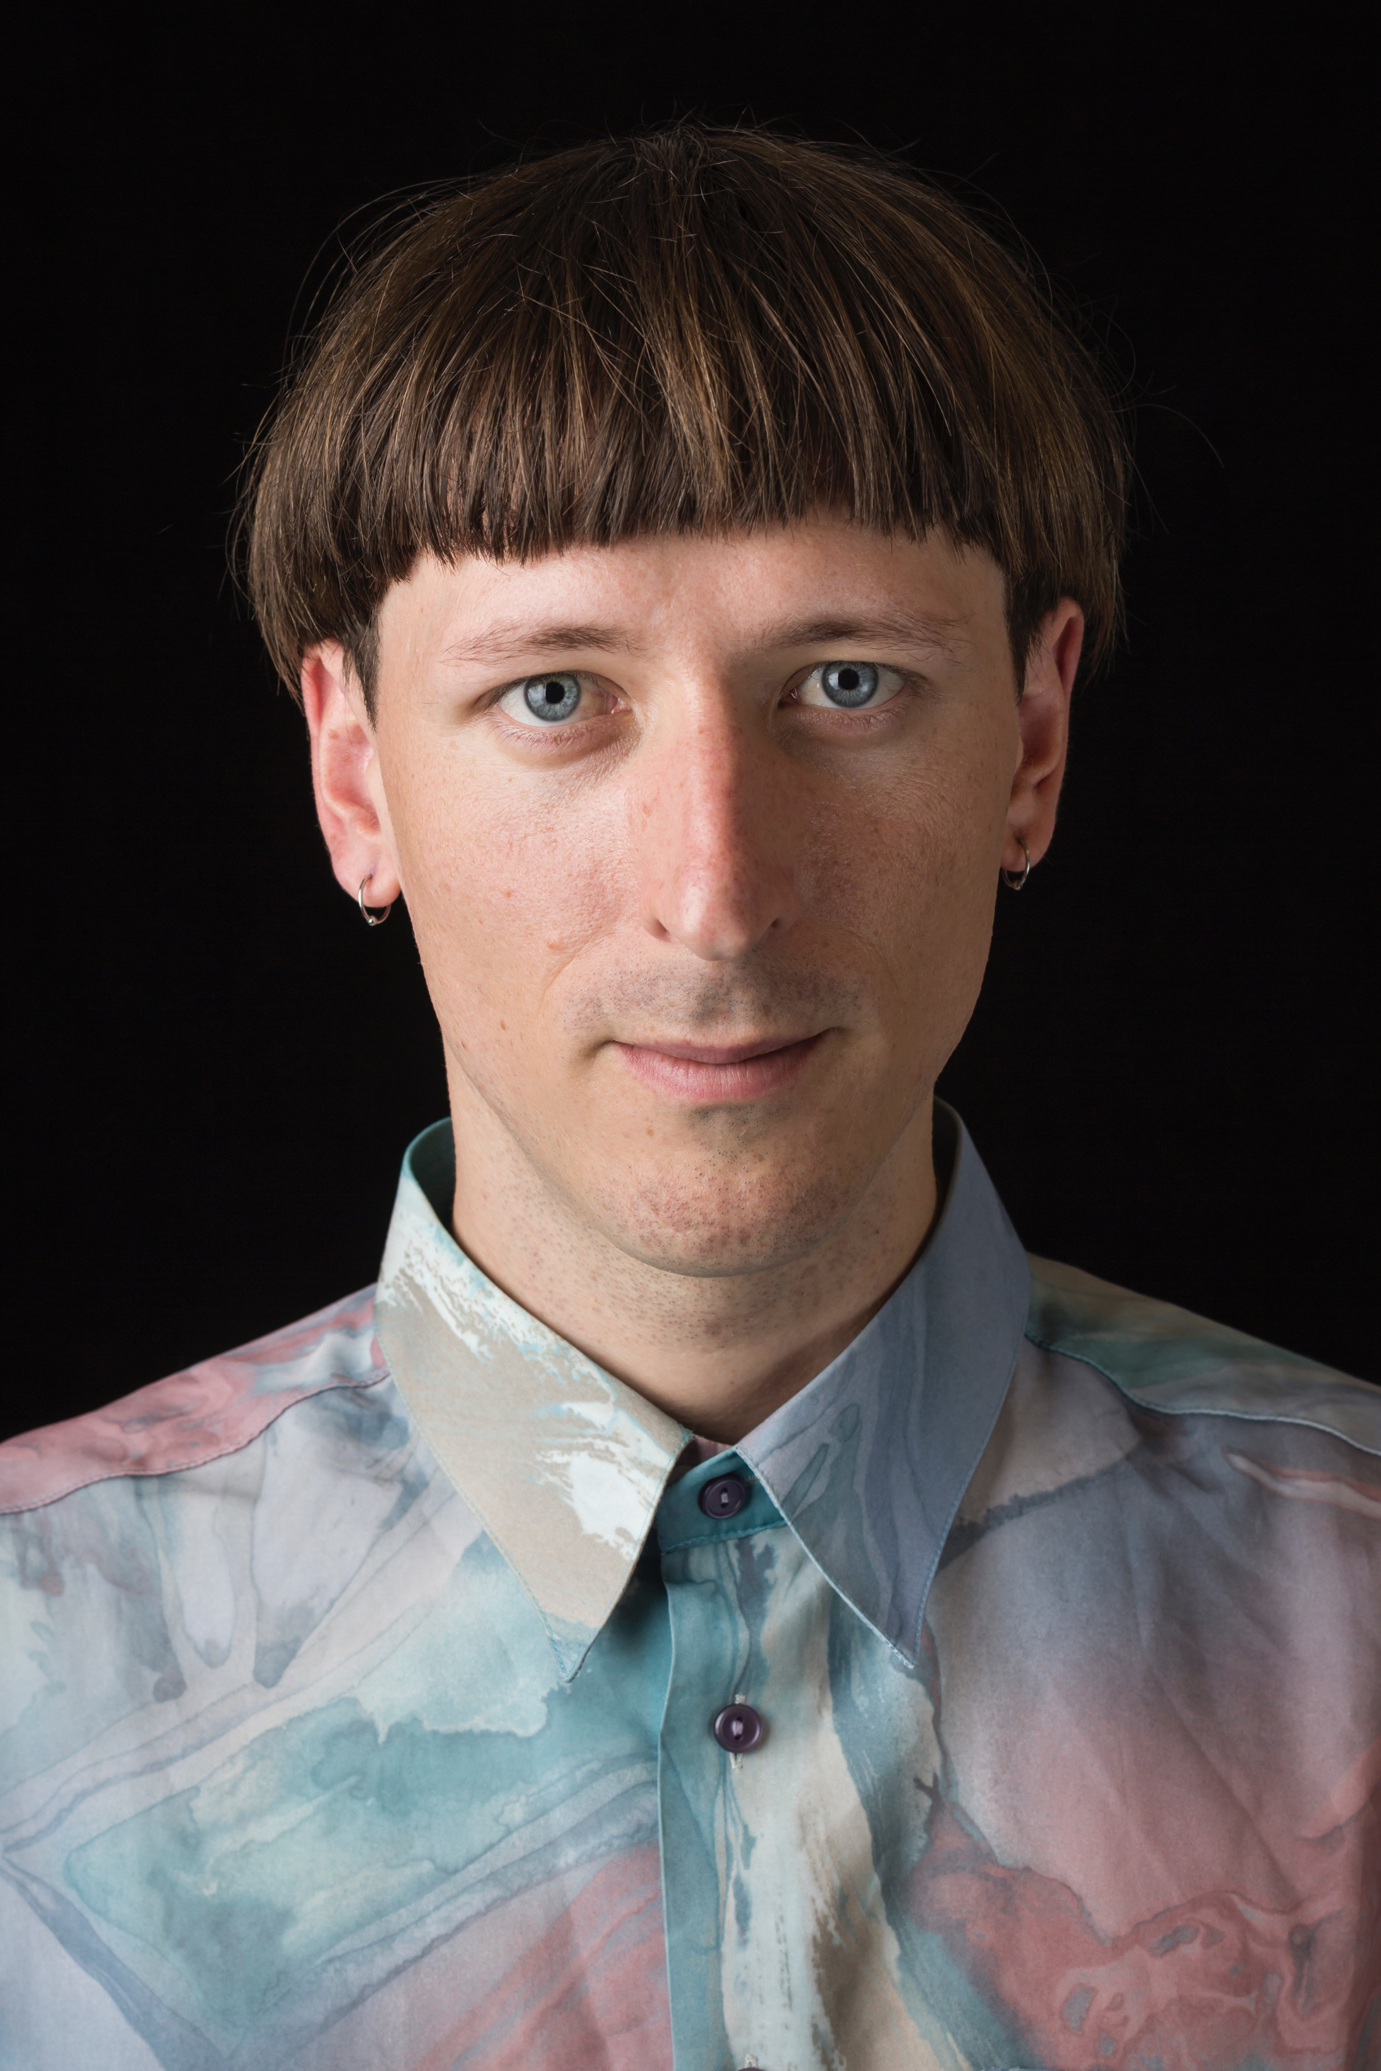Nick Moloney**

Lighting Assistant

Nick is currently in his third year of the Bachelor of Fine Arts-Production at the Victorian College of the arts and is interning with Katie Sfetkidis on Apokalypsis. He is an aspiring lighting designer, with a passion for collaboration and live performance. He appreciates the potential for lighting to affect an audience’s perception and experience, influencing their interpretation of a performance. After completing a Diploma of Live Production at Melbourne Polytechnic in 2014, he worked as a stage manager until deciding to pursue a career in lighting design. He has worked with a number of local lighting designers including Shane Grant, Niklas Pajanti, Scott Allan, Bronwyn Pringle, Jamie Henson and Rebecca Etchell. Some designs include *Peter Pan* (Victorian College of the Arts 2018), *Antigone X* (Theatreworks 2018), *Never* (VCA 2017), *re:moving* (VCA 2017) and *Blues in the Night* (Chapel Off Chapel 2016).

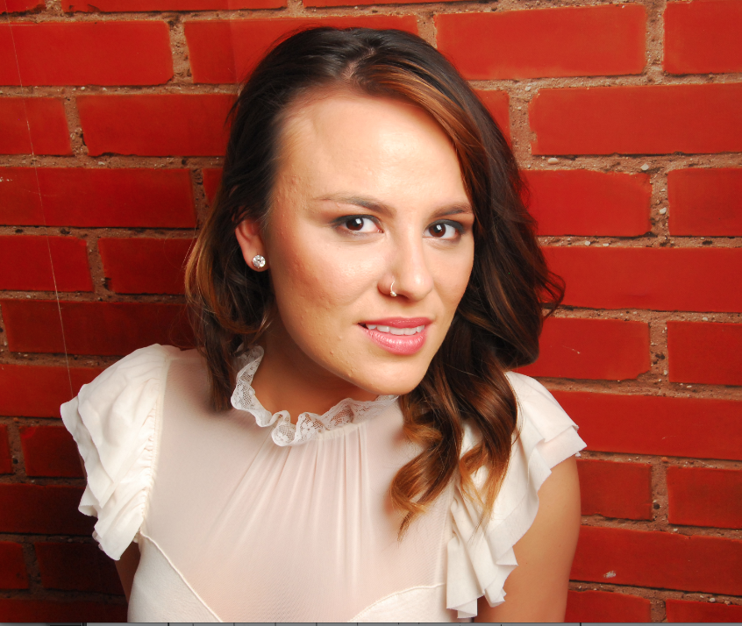

**Natasha Phillips**

Producer

Natasha is an independent Creative Producer based in Melbourne working across contemporary and experimental theatre and dance with a strong engagement with the Chinese speaking region. She was recently the Associate Producer at Arts House, a participant on the Australia Council Future Leaders program 2017 and a casual producer with Performing Lines. She has been a participant on the inaugural Women In Theatre program at MTC, the Emerging Cultural Leaders program at FCAC and is a recipient of the Australia Council Career Development grant and Ian Potter Cultural Trust. Her producing credits include *Apokalypsis* by Zak Pidd and Charles Purcell (Next Wave/The SUBSTATION 2018), *RESTORE/LARA* by Renae Shadler & Mirjam Sögner (Dancehouse YOUR WAY 2018), *Virgins and Cowboys* by Morgan Rose (Griffin Theatre Independent 2017), *TimePod* by Kat Henry (Testing Grounds 2017), *Andre Tonight!* by Chris Ryan and Mark Leonard Winter (Melbourne Fringe 2016), *RESTORE* by Renae Shadler (Melbourne Fringe 2016), *Towards Transparency* by Chloe Chignell (Melbourne Fringe 2015), *Macbeth* by RIFT (2014) and *London Stories: a 1-on-1-on-1 Festival* (Battersea Arts Centre 2013).

**Tonie-Rayne Steele**

Stage Manager

Tonie-Rayne is a 2014 graduate of the Victorian College of the Arts completing a Bachelor of Fine Arts in Production - Stage Management. Since graduating from the VCA, Tonie-Rayne has worked on a diverse number of projects including; *Saltwater* by Jamie Lewis (Theatre Works, Brisbane Festival), *The Nagambie Lakes Opera Festival* (The Opera Studio Melbourne 2015/2016), *GROUND CONTROL* by Bridget Balodis and Rachel Perks (Next Wave Festival, Brisbane Festival 2016), *HART* by She Said Theatre Company (The Blue Room Theatre Perth, Brisbane Festival, Melbourne Fringe 2016) and *We Were There* by Tilted Projects (Midsumma Festival 2018). Tonie-Rayne also works within the Events Sector. This has lead her to her work on a variety of events in the Melbourne area including St. Kilda Festival, the 2015, 16' and 17' Moomba Parade, the Opening Ceremony of the Asia Cup and the Opening Ceremony of the Rugby League World Cup 2017.

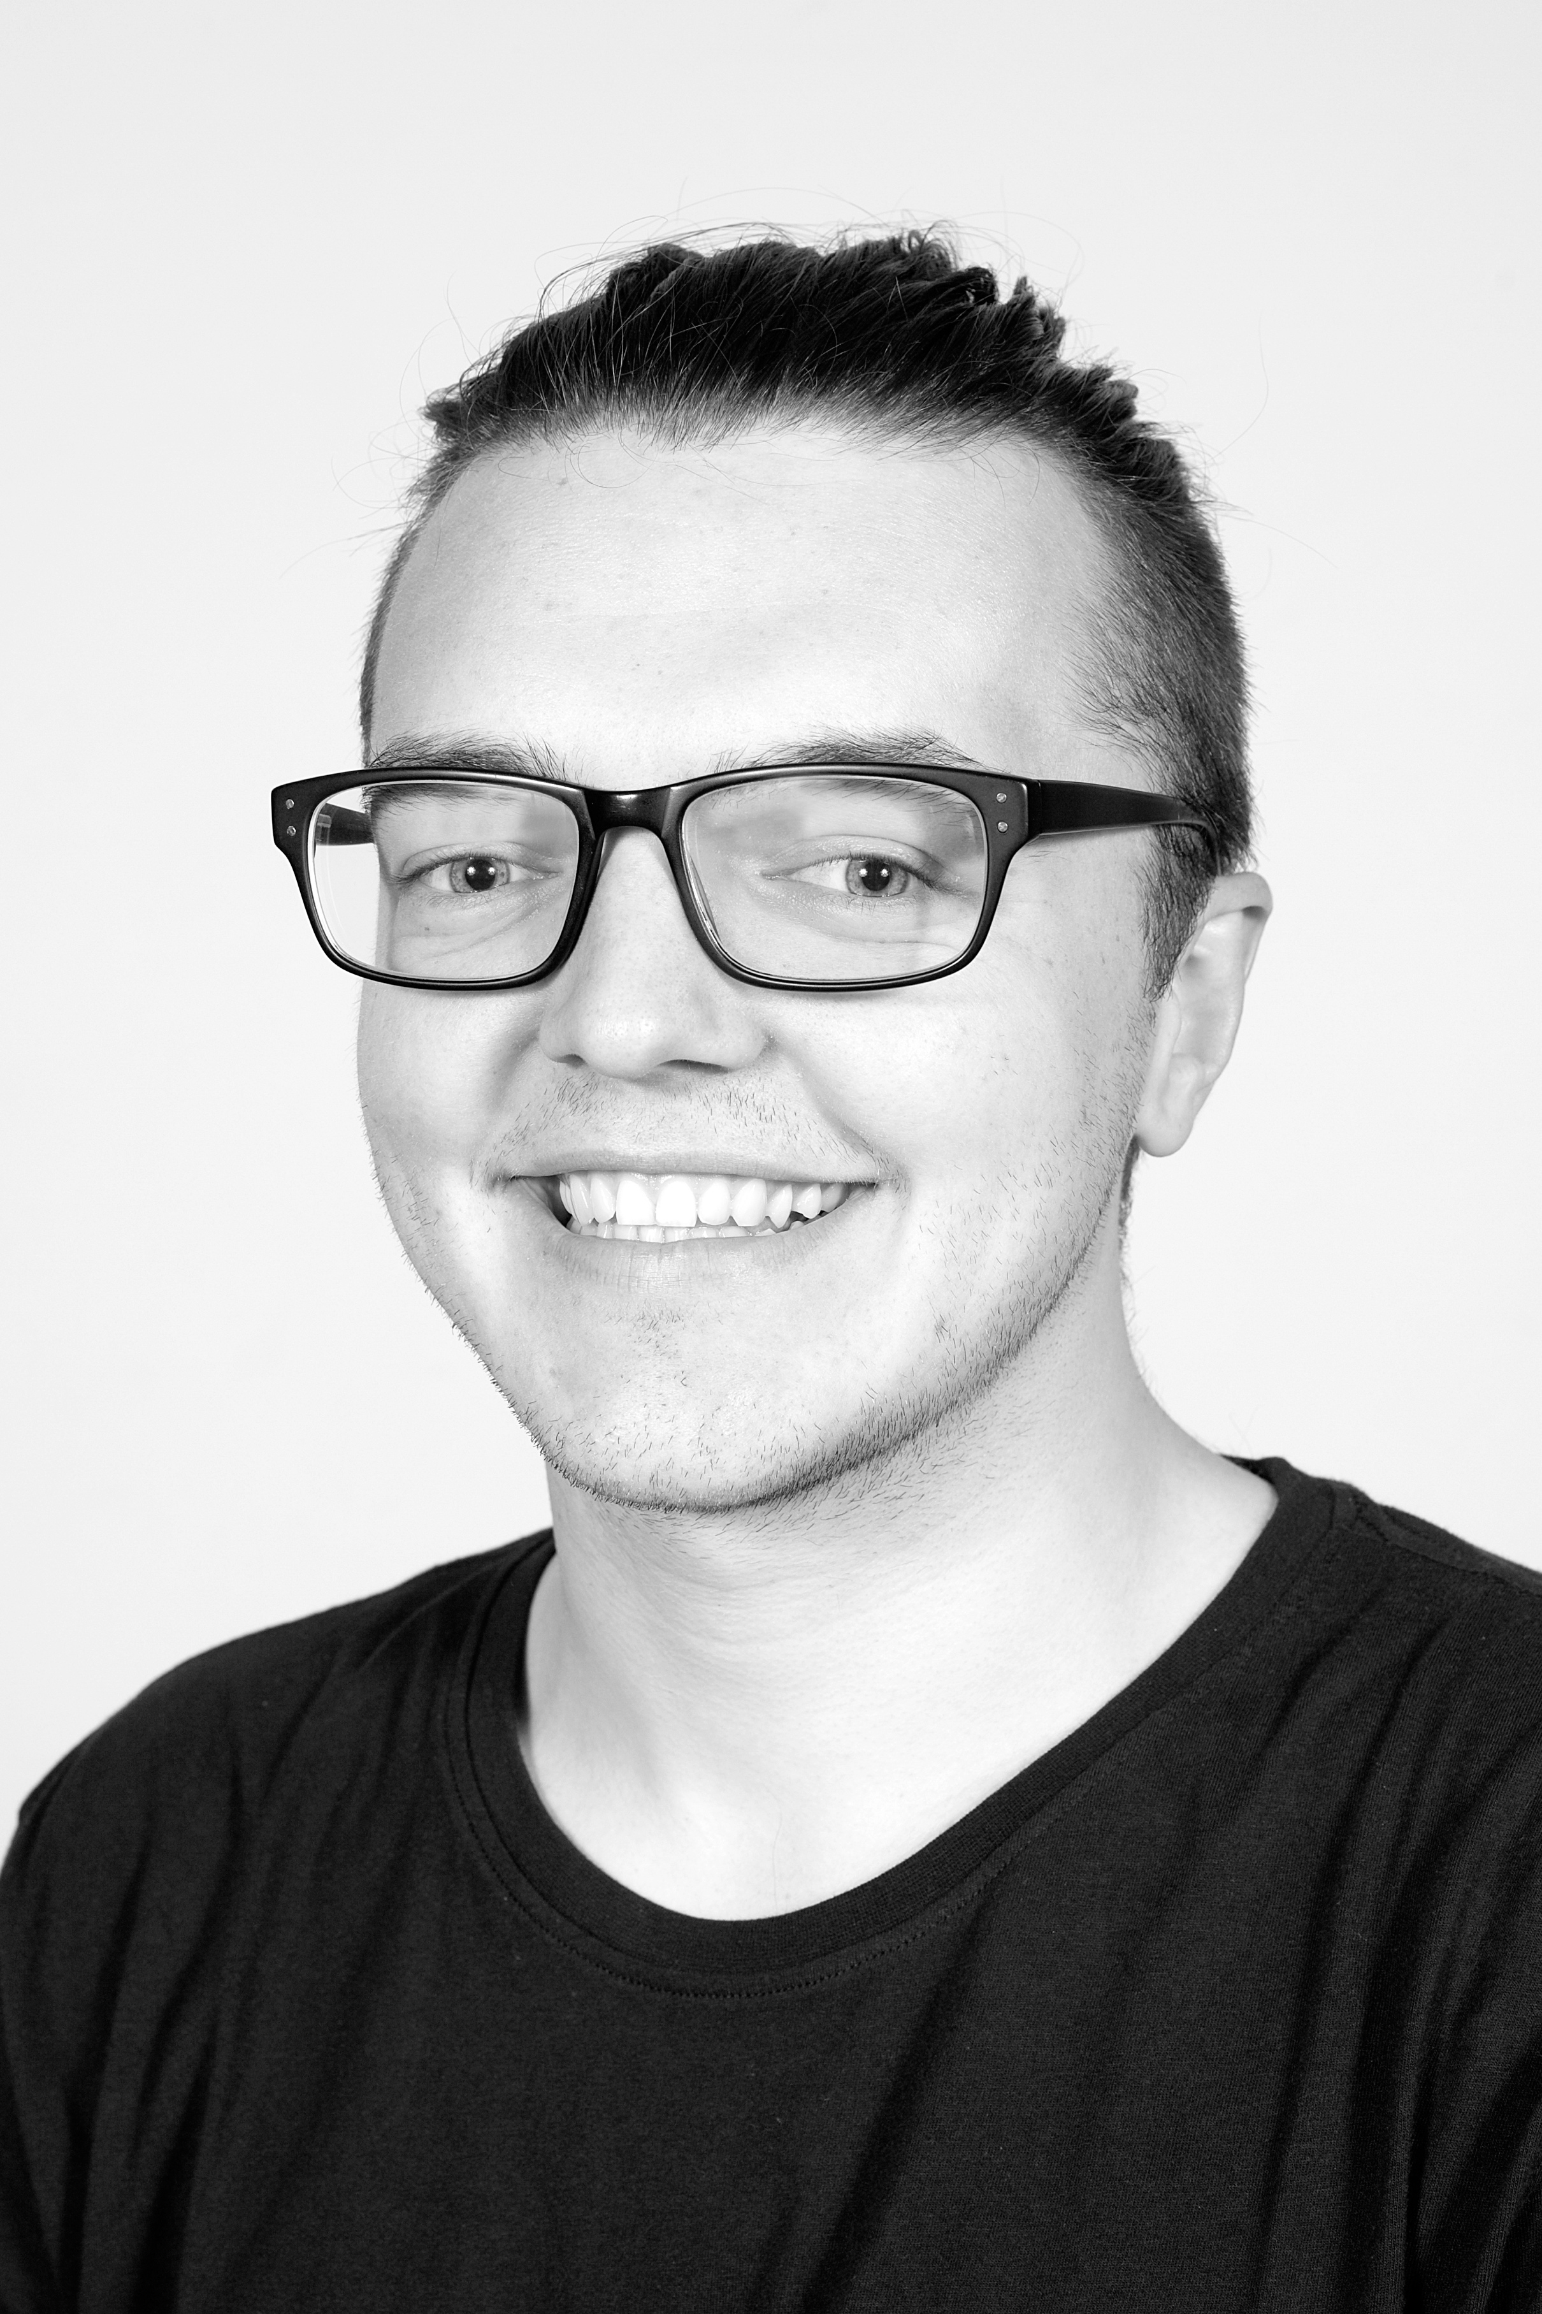

**Thomas Crawford**

Assistant Stage Manager

Thomas graduated with a Bachelor of Contemporary Arts in Theatre from the University of Tasmania in 2015. His previous theatre credits in various technical roles include *Colder* (Red Stitch Actors’ Theatre); *Dragged* (Midsumma Festival); *12 Angry Men* (Three River Theatre); *Dusty: The Original Pop Diva* (Launceston Musical Society*)*; *Evolve : revolve* (Tasdance); *One Day: Redux (*Mudlark Theatre*)*.

Special Thanks

Georgie Meagher, Erica McCalman, Bron Belcher, Will Foster and all of the Next Wave team

Brad, Rob, Marisa, Leela, Kali and everyone at The SUBSTATION

Silvia and Michael Kantor

Besen Family Foundation

Seaborn, Broughton and Walford Foundation

Creative Victoria

Bruce Gladwin

Stephen Armstrong

Melbourne Festival and Aaron Hock for their very generous lending of the surtitle machine

Cat Scobie

Lexie and everyone at Polyglot Theatre

NIDA

Brunswick Mechanics Institute

Susannah Day

David Geoffrey Hall

Emma Costello at Common State

Siteworks

Melbourne Theatre Company

Red Stitch Actors Theatre

Malthouse Theatre

Sue Giles

Ian Pidd

Rachel Perks

Daniel Schlusser

Hamish Irvine

Rinske Ginsberg

Sapidah Kian

Robert Walton

Jeff Sparrow

Dr. Christopher Fluke

Prof. Lesley Head

Marcel Dorney

Emily Tomlins

Olivia Satchell

Amelia Dowd

Nick Synott

Andrew Purcell

Susannah Throsby

Next Wave volunteers

2017 Kickstart Helix artists

Sponsors

Apokalypsis has been assisted by Besen Family Foundation, Silvia & Michael Kantor, Seaborn Broughton & Walford Foundation and Creative Victoria.



